 

A Project Report on

NAVIGATING THE SHOPPER’S TRAIL

Submitted in partial fulfillment of requirements for the award of the course

of

## ADI1211 – BUSINESS INTELLIGENCE

Under the guidance of

# Ms. S .SUBHA SRI M.E.,

## IBM Software Technical Trainer/AI&DS

Submitted By

## DHARSHINI K(927623BAD023),

## GOPIKAMBAL N(927623BAD036),

## KAARUNYA A S (927623BAD047).

**DEPARTMENT OF ARTIFICIAL INTELLIGENCE**

# M.KUMARASAMY COLLEGE OF ENGINEERING

(Autonomous)

**KARUR – 639 113**

May 2025

i

## M. KUMARASAMY COLLEGE OF ENGINEERING (Autonomous Institution affiliated to Anna University, Chennai)

**KARUR – 639 113**

## BONAFIDE CERTIFICATE

Certified that this project report on "**Navigating the Shopper's Trail**"is bonafide work of **DHARSHINI K( 927623BAD023), GOPIKAMBAL N(927623BAD036), KAARUNYA A S (927623BAD047)** who carried out the project work during the academic year 2024 - 2025 under my supervision.

Signature Signature

**Ms. S. Subha Sri ,M.E., Dr. A.SELVI (Ph.D.,)**

### IBM Software Technical Trainer, HEAD OF THE DEPARTMENT,

Department of Artificial Intelligence, Department of Artificial Intelligence,

M.Kumarasamy College of Engineering,

M.Kumarasamy College of Engineering,

 Thalavapalayam, Karur -639 113. Thalavapalayam, Karur -639 113.

## DEPARTMENT OF ARTIFICIAL INTELLIGENCE AND DATA SCIENCE

### VISION OF THE INSTITUTION

To emerge as a leader among the top institutions in the field of technical education

### MISSION OF THE INSTITUTION

* Produce smart technocrats with empirical knowledge who can surmount the global challenges
* Create a diverse, fully-engaged, learner-centric campus environment to provide quality education to the students
* Maintain mutually beneficial partnerships with our alumni, industry, and Professional associations

### VISION OF THE DEPARTMENT

To create highly qualified competitive professionals in Artificial Intelligence and Machine Learningby designing intelligent solutions to solve problems in variety of business domains, applications such as natural language processing, text mining, robotics, reasoning and problem

-solving that serves society with greater cause.

### MISSION OF THE DEPARTMENT

**M1:** Impart practical and technical knowledge along with applications of various integrated technologies.

**M2:** Design and develop various intelligent engineering projects to solve societal issues.

**M3:** Use of advanced engineering tools and equipment to enable research based learning to promote ethical values, lifelong learning and entrepreneurial skills.

### PROGRAM EDUCATIONAL OBJECTIVES (PEOS)

PEO1: Develop intelligent software solutions demonstrating reasoning, learning and decision support while handling uncertainty using domain knowledge.

PEO2: Create significant research towards social benefits and engineering improvement witha wide breadth knowledge of AI & ML technologies and their applications.

PEO3: Participate in life-long learning for effective professional growth and demonstrate leadership qualities in disruptive technologies along with a capacity to critically analyse and evaluate design proposals.

### PROGRAM OUTCOMES

Engineering students will be able to:

**PO1: Engineering knowledge:** Apply the knowledge of mathematics, science, engineering fundamentals, and an engineering specialization to the solution of complex engineering problems.

**PO2: Problem analysis:** Identify, formulate, review research literature, and analyze complex engineering problems reaching substantiated conclusions using first principles of mathematics, natural sciences, and engineering sciences.

**PO3: Design/development of solutions:** Design solutions for complex engineering problems and design system components or processes that meet the specified needs with appropriate consideration for the public health and safety, and the cultural, societal, and environmental considerations.

**PO4: Conduct investigations of complex problems:** Use research-based knowledge and research methods including design of experiments, analysis and interpretation of data, and synthesis of the information to provide valid conclusions.

**PO5: Modern tool usage:** Create, select, and apply appropriate techniques, resources, and modern engineering and IT tools including prediction and modeling to complex engineering activities with an understanding of the limitations.

**PO6: The engineer and society:** Apply reasoning informed by the contextual knowledge to assess societal, health, safety, legal and cultural issues and the consequent responsibilities relevant to the professional engineering practice.

**PO7: Environment and sustainability:** Understand the impact of the professional engineering solutions in societal and environmental contexts, and demonstrate the knowledge of, and need for sustainable development.

**PO8: Ethics:** Apply ethical principles and commit to professional ethics and responsibilities and norms of the engineering practice.

**PO 9: Individual and team work:** Function effectively as an individual, and as a member or leader in diverse teams, and in multidisciplinary settings.

**PO10: Communication:** Communicate effectively on complex engineering activities with the engineering community and with society at large..

**PO11: Project management and finance:** Demonstrate knowledge and understanding of the engineering and management principles and apply these to one’s own work, as a member and leader in a team, to manage .

**PO12: Life-long learning:** Recognize the need for, and have the preparation and ability to engage in independent and life-long learning in the broadest context of technological change.

### PROGRAM SPECIFIC OUTCOMES (PSOs)

**PSO1:** Expertise in tailoring ML algorithms and models to excel in designated applications and fields.

**PSO2:** Ability to conduct research, contributing to machine learning advancements and innovations that tackle emerging societal challenges.

# ABSTRACT

"Navigating the Shopper's Trail" is a comprehensive business intelligence project developed to revolutionize retail analytics by harnessing the power of IBM Cognos Analytics. This system provides a centralized platform to track, analyze, and visualize shopper behavior, sales dynamics, and inventory performance. Through this project, retailers are empowered with actionable insights into customer purchase patterns, regional trends, seasonal fluctuations, and promotion effectiveness. These insights are visualized via a secure, interactive dashboard that supports real-time decision-making and operational optimization. The integration of multiple datasets, external variables, and advanced security ensures accuracy, relevance, and confidentiality of the data.

# ABSTRACT WITH POs AND PSOs MAPPING

|  |  |  |
| --- | --- | --- |
| **ABSTRACT** | **POs**  **MAPPED** | **PSOs**  **MAPPED** |
| "Navigating the Shopper's Trail" is a comprehensive business intelligence project developed to revolutionize retail analytics by harnessing the power of IBM Cognos Analytics. This system provides a centralized platform to track, analyze, and visualize shopper behavior, sales dynamics, and inventory performance. Through this project, retailers are empowered with actionable insights into customer purchase patterns, regional trends, seasonal fluctuations, and promotion effectiveness. These insights are visualized via a secure, interactive dashboard that supports real-time decision-making and operational optimization. The integration of multiple datasets, external variables, and advanced security ensures accuracy, relevance, and confidentiality of the data. | PO1(3)  PO2(3)  PO3(3)  PO4(2)  PO5(3)  PO6(2)  PO7(2)  PO8(1)  PO10(2)  PO11(2)  PO12(2) | PSO1(1)  PSO2(2) |

Note: 1- Low, 2-Medium, 3- High

**SUPERVISOR HEAD OF THE DEPARTMENT**

# TABLE OF CONTENTS

|  |  |  |
| --- | --- | --- |
| **Chapter No.** | **Title** | **Page No.** |
| 1 | Introduction | 1 |
| 2 | Project Objective | 1 |
| 3 | Tools Used | 2 |
| 4 | Dataset Overview | 3 |
| 5 | Key Visualizations | 4 |
| 6 | Security Features Implemented | 5 |
| 7 | Insights Derived | 5 |
| 8 | Screenshots of Dashboard | 6 |
| 9 | Conclusion | 7 |

**INTRODUCTION:**

The modern retail landscape is increasingly data-driven. With the exponential growth in customer data   sales transactions, loyalty programs, and digital footprints, businesses face the challenge of transforming raw data into usable intelligence. Traditional systems often lack real-time capabilities and central integration, leading to fragmented insights.

"Navigating the Shopper’s Trail" addresses these shortcomings by consolidating disparate     data  sources  into an intelligent business dashboard built with IBM Cognos Analytics. The platform offers visually rich, real-time insights into customer purchasing behavior, sales patterns, and inventory efficiency. It enables retailers to identify demand shifts, personalize services, and improve overall store performance.

## 1. PROJECT OBJECTIVE :

* To design a centralized BI dashboard that displays key retail metrics in an understandable, visual format.
* To examine the influence of factors like weather, promotions, and demographics on customer purchase decisions.
* To track performance indicators such as total revenue, best-selling categories, and peak shopping periods.
* To provide differentiated access through a secure, role-based login system ensuring authorized access to data.

## 

## 2.TOOLS USED :

The primary tool utilized for this project is:

**IBM Cognos Analytics**

IBM Cognos Analytics is an advanced business intelligence (BI) and data visualization platform that enables organizations to transform raw data into meaningful insights. It was selected for this project due to its powerful capabilities in building dynamic, secure, and interactive dashboards.

Key reasons for choosing IBM Cognos Analytics include:

* **Interactive Dashboards**: Allows users to explore data visually through charts, graphs, and custom filters that enable analysis of registration trends, program popularity, and member retention.
* **Security and Governance**: Provides robust security features including role-based access control, user authentication, and secure sharing of reports—ensuring that only authorized users (e.g., owners vs. members) can access sensitive data.
* **Data Integration**: Supports easy integration of various data sources (CSV, Excel, databases, etc.) to create a unified view of membership and financial data.
* **Custom Visualizations**: Offers a wide range of customizable visual elements suited for fitness metrics such as attendance patterns, spending behavior, and registration sources.
* **HTML, CSS** – For enhancing the user interface of the dashboard frontend and embedding visuals into a website.

# 3.DATASET OVERVIEW:

# 

# 

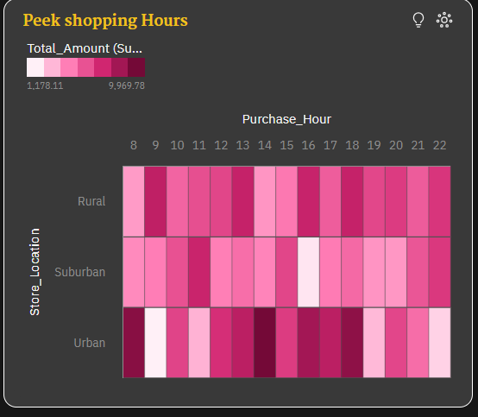

**5. KEY VISUALIZATION:**

**1.Sales by Category (Heatmap)**

**Purpose**: To identify the top-performing product categories.

**Insight**: Home and grocery items dominate sales, indicating consistent consumer preference

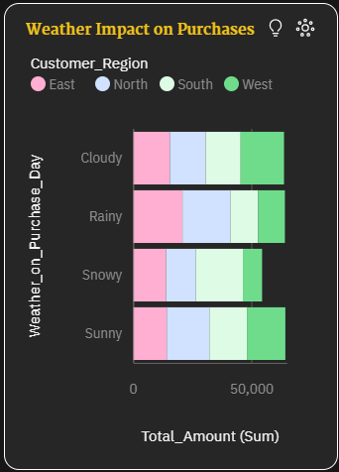

.

**2.Weather Impact on Purchases (Bar Chart)**

**Purpose**: To observe sales variations based on weather conditions.

**Insight**: Sunny weather is linked with higher purchases of outdoor and seasonal products.

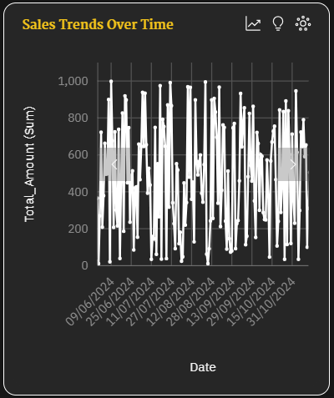

**3.Sales Trends Over Time (Line Chart)**

**Purpose**: To track sales fluctuations and identify peak periods.

**Insight**: Noticeable spikes during holiday seasons and promotional events.

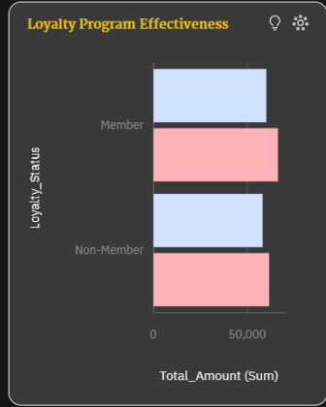

**4.Customer Loyalty Distribution (Bar chart)**

**Purpose**: To categorize customers into first-time and repeat buyers.

**Insight**: Returning customers contribute a higher share of overall revenue.

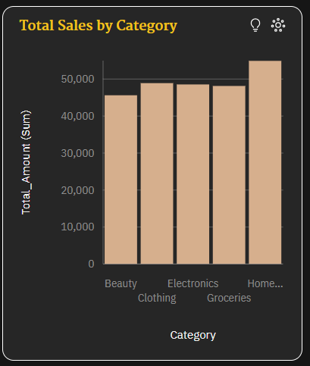

**5.Total Sales by Category (Bar Chart)**

**Purpose**: To compare total sales across different product categories.

**Insight**: Home category has the highest sales, while other categories like Beauty, Clothing, Electronics, and Groceries have similar sales figures.

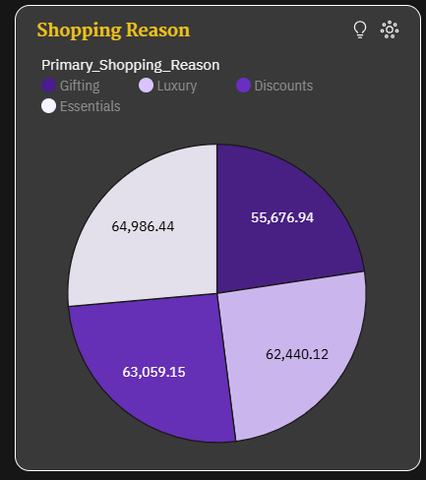

## Shopping Reason (Pie Chart)

## Purpose: To understand the main reasons why customers shop.

## Insight: Essentials is the top reason, followed by Discounts and Luxury, with Gifting being the least common reason.

Security is paramount in data analytics. The following measure were incorporated:

* **Role-Based Access Control** – Different users such as store managers, executives, and analysts are assigned specific access privileges.
* **User Authentication** – A secure login system ensures that only verified users can enter the analytics dashboard.
* **Data Privacy Mechanisms** – Sensitive information is protected through restricted access, masking of personal data, and Cognos-level permission layers.

## 7.INSIGHTS DERIVED:

* Sunny weather has a strong positive correlation with increased in-store traffic and sales of outdoor or home-related products.
* The grocery and home product categories consistently show top performance in revenue and volume.
* Analysis reveals peak shopping activity between 5 PM and 8 PM on weekdays and during early afternoon on weekends.
* Loyal, repeat customers account for a significantly higher average basket size compared to first-time buyers.
* Stockout patterns show a need for improved demand forecasting and real-time inventory alerts.
* Social media and website registrations account for a substantial share of new customer signups, highlighting the success of digital campaigns.

## SCREENSHOT OF DASHBOARD:

## 

## 

## Screenshot 2025-05-12 154622

## 9.CONCLUSION:

## 

The "Navigating the Shopper’s Trail" project demonstrates the impactful role that business intelligence can play in the retail industry. By integrating multiple datasets into a cohesive, real-time dashboard built on IBM Cognos Analytics, retailers gain invaluable insights into shopper behavior, operational efficiency, and market responsiveness.

This system not only simplifies decision-making but also enables predictive planning and proactive adjustments. The project successfully addresses challenges related to fragmented data, delayed reporting, and reactive strategies. Going forward, such systems can be enhanced with machine learning models to forecast demand, personalize offers, and automate recommendations.

In essence, the project transforms the retail data ecosystem into a smart, secure, and strategic advantage for business growth.